05 November 2021
NEW ARRANGEMENTS FOR SUPPORTING CHILDREN AND YOUNG PEOPLE WITH SPECIAL EDUCATION NEEDS AND DISABILITIES
Dear Parent / Carer
Additional Learning Needs and Education Tribunal Act (ALNET 2018)
The system for supporting children and young people with special educational needs and disability in Wales is changing. The Welsh Government is bringing in a new more flexible and responsive system to meet the needs of children with special educational needs or disabilities.
The new system will ensure that:
- Needs are identified early, addressed quickly and all learners are supported to reach their potential.
- Our professionals are skilled and confident in identifying needs and using strategies to help learners.
- The learner is at the centre of everything we do, and they and their parents and carers are equal partners in their learning. This is called a Person Centred Approach.
The new system will be brought in gradually over the next few years (2021 - 2024) in accordance with Welsh Government guidance. Here are some of the key messages about these changes and what they may mean for you and your child.
Key Messages
- The term Additional Learning Needs (ALN) will replace the terms Special Educational Needs (SEN) and Learning Difficulties and Disabilities (LDD)
- Special Educational Needs Coordinators (SENCos) in schools will now be called Additional Learning Needs Coordinators (ALNCos)
- The mandatory ALN Code for the new system will cover children and young people aged 0-25. This means that early years and further education colleges will have duties under the Act, but this does not include higher education or apprenticeships.
- If your child is on School Action / School Action Plus or they have a Statement of Special Needs, this will change over the next 3 years. All children and young people with an identified additional learning need (ALN) that requires additional learning provision (ALP) will have an Individual Development Plan (IDP). The IDP will replace Individual Education Plans (IEPs) and Statements of SEN.
- Most Individual Development Plans will be the responsibility of the school but in some circumstances, they may be maintained by the Local Authority. IDPs for children under compulsory school age, who require them, for example in the early years will be the responsibility of local authorities.
- The ALNET Act expects that everyone involved with your child e.g. Childcare settings, Education, Health and Social Care will work in collaboration to support children and young people with ALN.
- There will be increased opportunities for children, young people, parents and carers to contribute to Individual Development Plans.
- It is expected that working together more closely should help to avoid disagreements.
- All reasonable steps will be taken to ensure additional learning provision will be provided in Welsh, if required.
Additional Information
The interactive e-learning course giving an introduction to the new ALN system is available on either of these links:
https://hwb.gov.wales/news/articles/20686965-8669-40ac-bdc5-599f4a4dfe8b
https://hwb.gov.wales/repository/publishers/9fb2afc9-6408-4aa3-9474-3c745006535b/resource/c8033263-aaa0-42fc-9511-ab7d33bd8084/en
Swansea LA has appointed a team of ALN Caseworkers to support families of children with Additional Learning Needs. Please contact your school ALNCo for more information.
Leaflets explaining the changes in more detail can be accessed on the school website by clicking the following link: https://www.pennardprimary.co.uk/additional-learning-needs/
If you would like any additional information or advice, please visit the Swansea Local Authority website at www.swansea.gov.uk/aln
Our school has its own information on our web-site at https://www.pennardprimary.co.uk/additional-learning-needs/
Yours faithfully,
Kerina Hanson (Headteacher)
Mrs C. Dardecker (ALNCO).



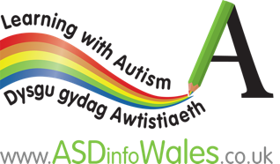
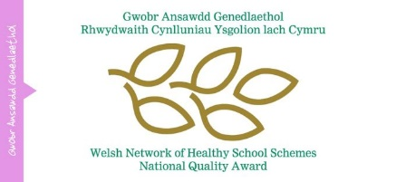



Dream, Believe, Achieve Together – Breuddwydio, Credu, Cyflawni Gyda’n gilydd

