Cymraeg
Developing Literacy
Foundation Phase Learning Apps

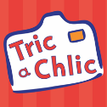
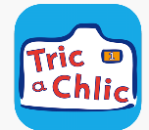
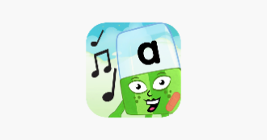
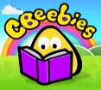
Tric a Chlic 1 a 2: A Welsh language app to reinforce letter sounds and formation, with songs to lead you from letter to letter. Games provide opportunities to practice and use the skills taught within the scheme.
Meet the Alphablocks: Letter sounds, letter names and initial sound objects
CBeebies Storytime: Interactive storybooks, fairy tales and nursery rhymes

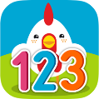
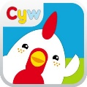
Cyw Welsh Apps: Welsh stories and songs that can be listened to. Games and puzzles.
Pocket Phonics: Letter sounds, formation and positioning on the line. Digraphs and double letters
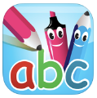
Developing Numeracy
Maths age 4-6: Teaches and develops mathematical understanding.

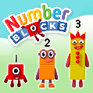
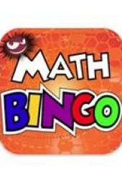
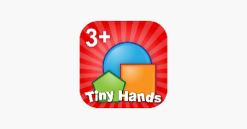
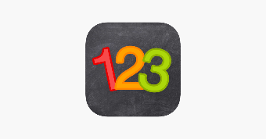
Genius 123: Counting, matching and tracing numbers
Maths age 3-5: Teaches and develops mathematical understanding.
Math Bingo: Fun games that target addition, subtraction, division and multiplication
Tiny Hands Puzzles & Shapes: Sorting and classifying by colour, size and shape
Meet the Numberblocks: Numberblock introduction, counting and number recognition



Multi-Sensory
Alternative Ways of Recording

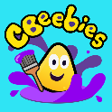
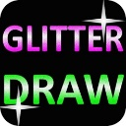

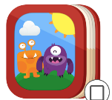

Glitter Draw: Can be used to practice letter writing letters, numbers, name or words. Fine motor development
CBeebies Get Creative: Can paint, build with blocks, make music, create stories or invent toys.
My Story: Good for younger children to create books/stories. Can create talking books
Puppet Pals: Role play, alternative ways of recording, creative play, animation and creating stories.
Book Creator: Creating own books and stories. Alternative ways of recording.

Other learning
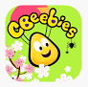
CBeebies Go Explore: Various learning games using familiar Cbeebies characters including Alphablocks and Hey Dougee

